A close up of a piece of paper

Description generated with high confidence

Ninong & Ninang

Barbelyn D. Biol

Meralyn G. Cosme

Gwendolyn B. Cinco

Gleen Ar B. Cinco

Bebeng O. Tana

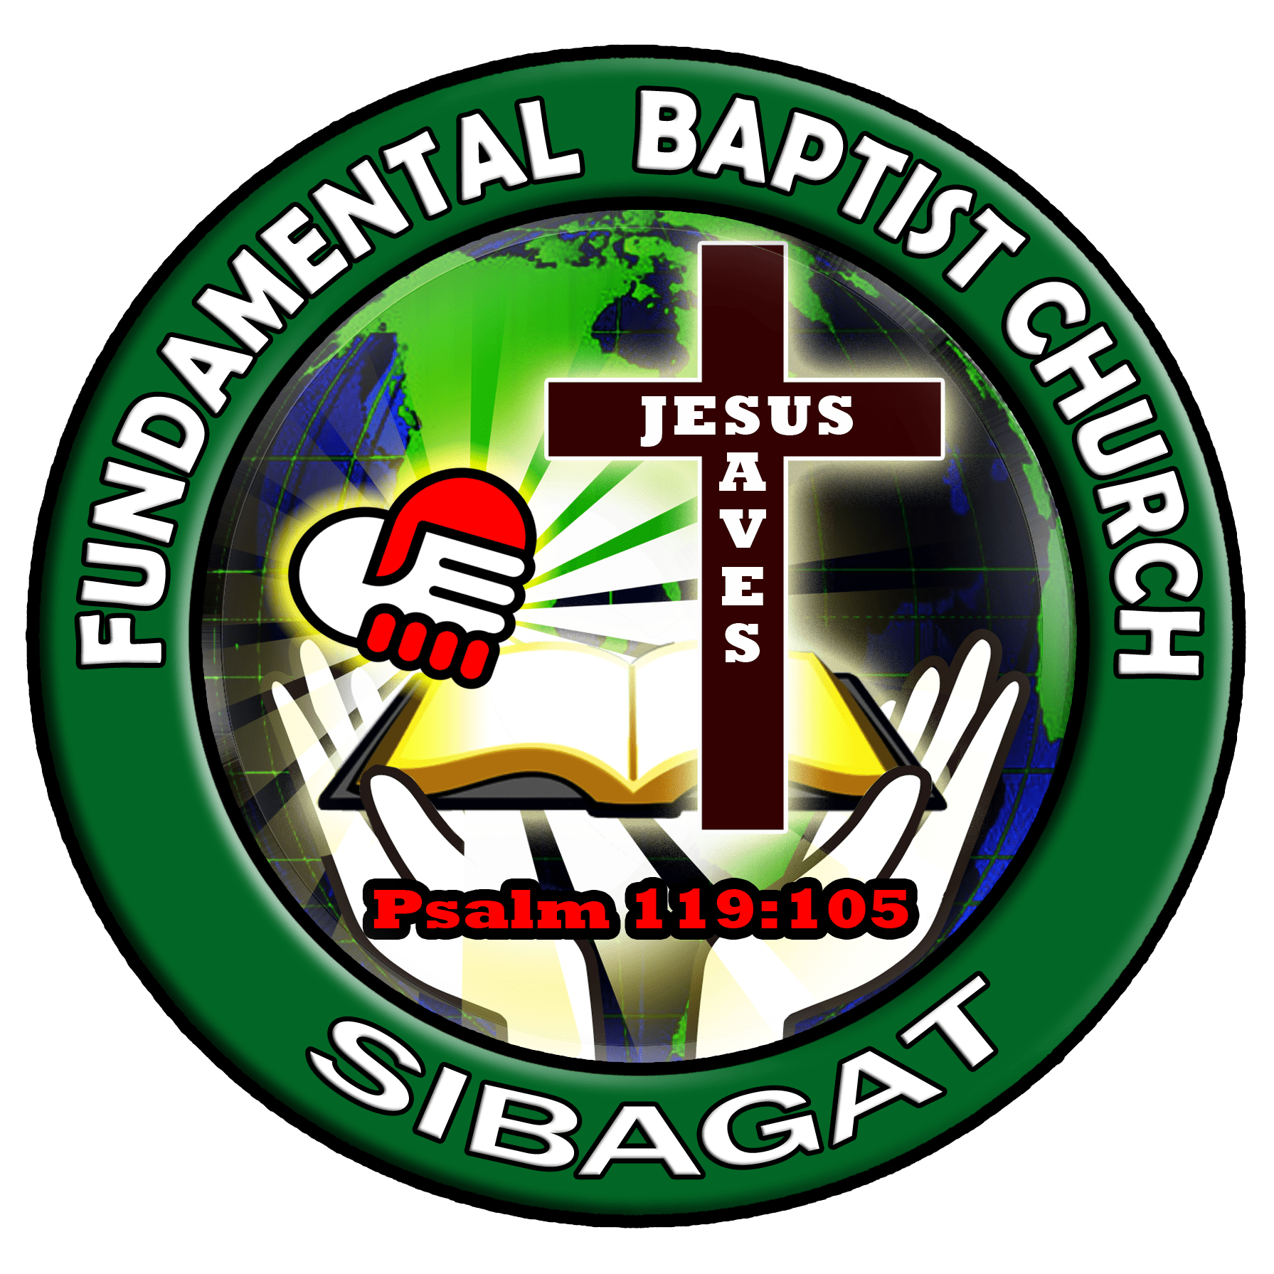



*"Children are a heritage from the Lord, offspring a reward from him.".*

*Psalm 127:3*